EXPERIMENT - 6

ROLL.NO: 240701506 NAME: SHREYA KS

Simulate the lifecycle stages for UI design using the RAD model and develop a small interactive interface using Axure RP

AIM:
The aim is to demonstrate the lifecycle stages of UI design via the RAD model and develop a small interactive interface employing Axure RP.

PROCEDURE:

Tool Link: https://www.axure.com/

Simulating the Lifecycle Stages for UI Design Using the RAD Model RAD Model (Rapid Application Development):

The RAD model emphasizes quick development and iteration. It consists of the following phases:

1. Requirements Planning:
○ Gather initial requirements and identify key features of the UI.
○ Engage stakeholders to understand their needs and expectations.

2. User Design:
○ Create initial prototypes and wireframes.
○ Conduct user feedback sessions to refine the designs.
○ Use tools like Axure RP to develop interactive prototypes.

3. Construction:
○ Develop the actual UI based on the refined designs.
○ Perform iterative testing and feedback cycles.

4. Cutover:
○ Deploy the final UI.
○ Conduct user training and support. Axure RP Interactive Interface
Development

Phase 1: Requirements Planning

1. Identify Key Features:
○ Navigation (Home, Product Categories, Product Details, Cart, Checkout, Order Confirmation, Order History)
○ User actions (Browsing, Searching, Adding to Cart, Checkout, Tracking Orders) 2. Create a Requirements Document:
○ List all features and functionalities.
○ Document user stories and use cases.

Phase 2: User Design

1. Install and Launch Axure RP:
○ Download and install Axure RP from Axure's official website.
○ Launch the application.

2. Create a New Project:
○ Go to File -> New to create a new project.
○ Name the project (e.g., "Shopping App Interface").

3. Create Wireframes:
○ Use the widget library to drag and drop elements onto the canvas.
○ Design wireframes for each screen:
■ Home Page
■ Product Categories
■ Product Listings
■ Product Details
■ Cart
■ Checkout
■ Order Confirmation
■ Order History

4. Add Interactions:
○ Select an element (e.g., button) and go to the Properties panel.
○ Click on Interactions and choose an interaction (e.g., OnClick).
○ Define the action (e.g., navigate to another screen).

5. Create Masters:
○ Create reusable components (e.g., headers, footers) using Masters.
○ Drag and drop masters onto the wireframes.
6. Add Annotations:
○ Add notes to describe each element's purpose and functionality.
Use the Notes panel to add detailed annotations.

Phase 3:

Construction

1. Develop Interactive Prototypes:
○ Convert wireframes into interactive prototypes by adding interactions and transitions.
○ Use dynamic panels to create interactive elements (e.g., carousels, pop-ups).

2. Test and Iterate:
○ Preview the prototype using the Preview button.
○ Gather feedback from users and stakeholders.
○ Make necessary adjustments based on feedback.

Phase 4:

Cutover

1. Finalize and Export:
○ Finalize the design and interactions.
○ Export the prototype as an HTML file or share it via Axure Cloud.

2. User Training and Support:
○ Conduct training sessions to familiarize users with the new interface.
○ Provide documentation and support for any issues.

OUTPUT: Example Interface Layout:
Home Page:
● Navigation Bar: Home, Categories, Cart
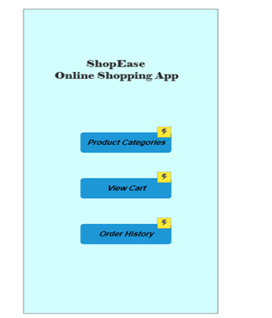
● Search Bar
● Featured Products Section Product Categories:
● List of Categories (e.g., Electronics, Clothing, etc.) Product Listings:
● Grid/List view of products with images, names, and prices Product Details:

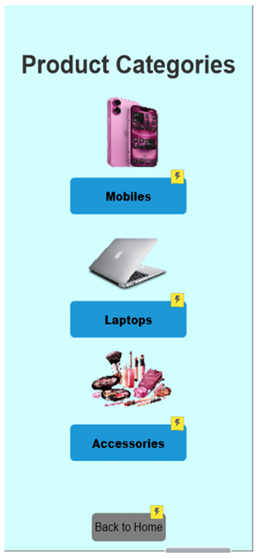
● Product Image

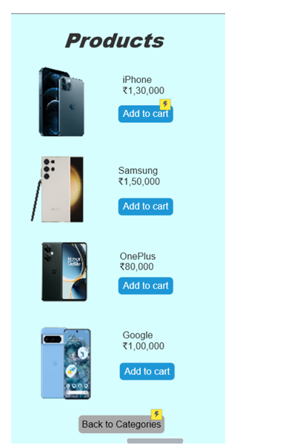

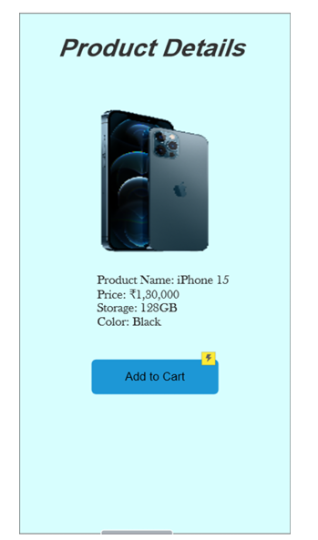
● Description
● Price
● Add to Cart Button Cart:

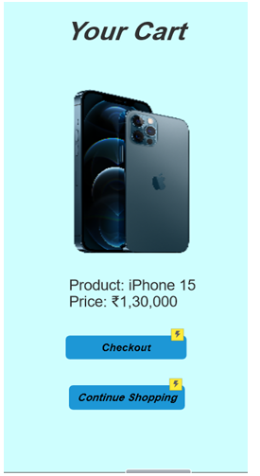

● List of items added to the cart
● Quantity, Price, Remove option
● Proceed to Checkout Button Checkout:
● Shipping Information
● Payment Information

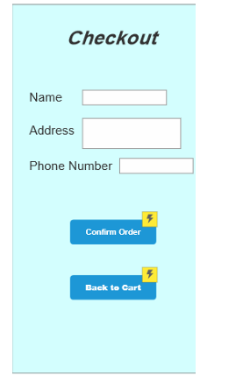
● Review Order
● Confirm Order Button Order Confirmation:
● Order Summary
● Order Status
● Track Order Link Order History:

